**T.C.  
 FIRAT ÜNİVERSİTESİ  
 MÜHENDİSLİK FAKÜLTESİ   
 BİLGİSAYAR MÜHENDİSLİĞİ  
MİCROİŞLEMCİLER LABARATUAR ÖDEV RAPORU**

**Simulasyon:** *PROTEUS-ISIS 7 PROFESSİONAL  
 **Editör** **:**\*MPLAB IDE V8.76

**Burhan GÖKTEKİN**  
 **09260026**

list p=16F877A  
include "p16F877a.inc"  
 pvm_sayaci EQU 0x21  
 temp EQU 0x22   
 ORG 0  
 goto ana_program  
 ORG 4  
 goto kesme  
ana_program  
 movlw d'15'  
 movwf pvm_sayaci  
 banksel INTCON  
 movlw b'11010000'  
 movwf INTCON  
 banksel TRISB  
 movlw b'00000001'   
 movwf TRISB  
 movlw d'0'  
 movwf TRISC  
 banksel PORTC  
 clrf PORTC  
 bcf PORTC,2  
 banksel PR2  
 movlw d'49'  
 movwf PR2  
 banksel CCPR1L  
 movlw b'00000111'  
 movwf CCPR1L  
 banksel CCP1CON  
 movlw b'00101100'  
 movwf CCP1CON  
 banksel PIE1  
 movlw d'2'  
 movwf PIE1;tmr2 pr2 eşleşmesıne kesmesıne ızın verme bıtı  
 banksel T2CON  
 movlw b'00000101'  
 movwf T2CON;presscaler t2 ye aktif yaptık  
dongu   
 goto dongu  
kesme   
 btfss INTCON,1  
retfie   
bcf INTCON,1

decfsz pvm_sayaci,f  
 goto artir  
 goto dongu  
artir  
 movlw b'00000001'  
 movwf temp  
 btfss temp,0  
 goto durum2  
 banksel CCPR1L  
 movlw b'00000011'  
 addwf CCPR1L,1  
 banksel CCP1CON  
 bcf CCP1CON,5  
durum2  
 banksel CCPR1L  
 movlw b'00000010'  
 addwf CCPR1L,1  
 banksel CCP1CON  
 bsf CCP1CON,5  
retfie  
end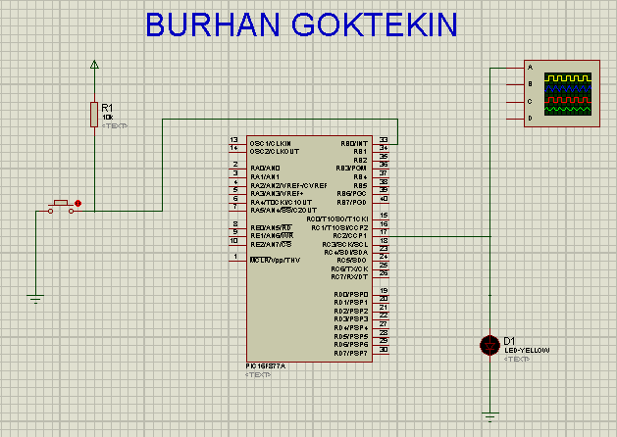 **Şekil:** Ödevin PROTEUS-ISIS simülasyon benzetimi.